Agri‐Business Child Development
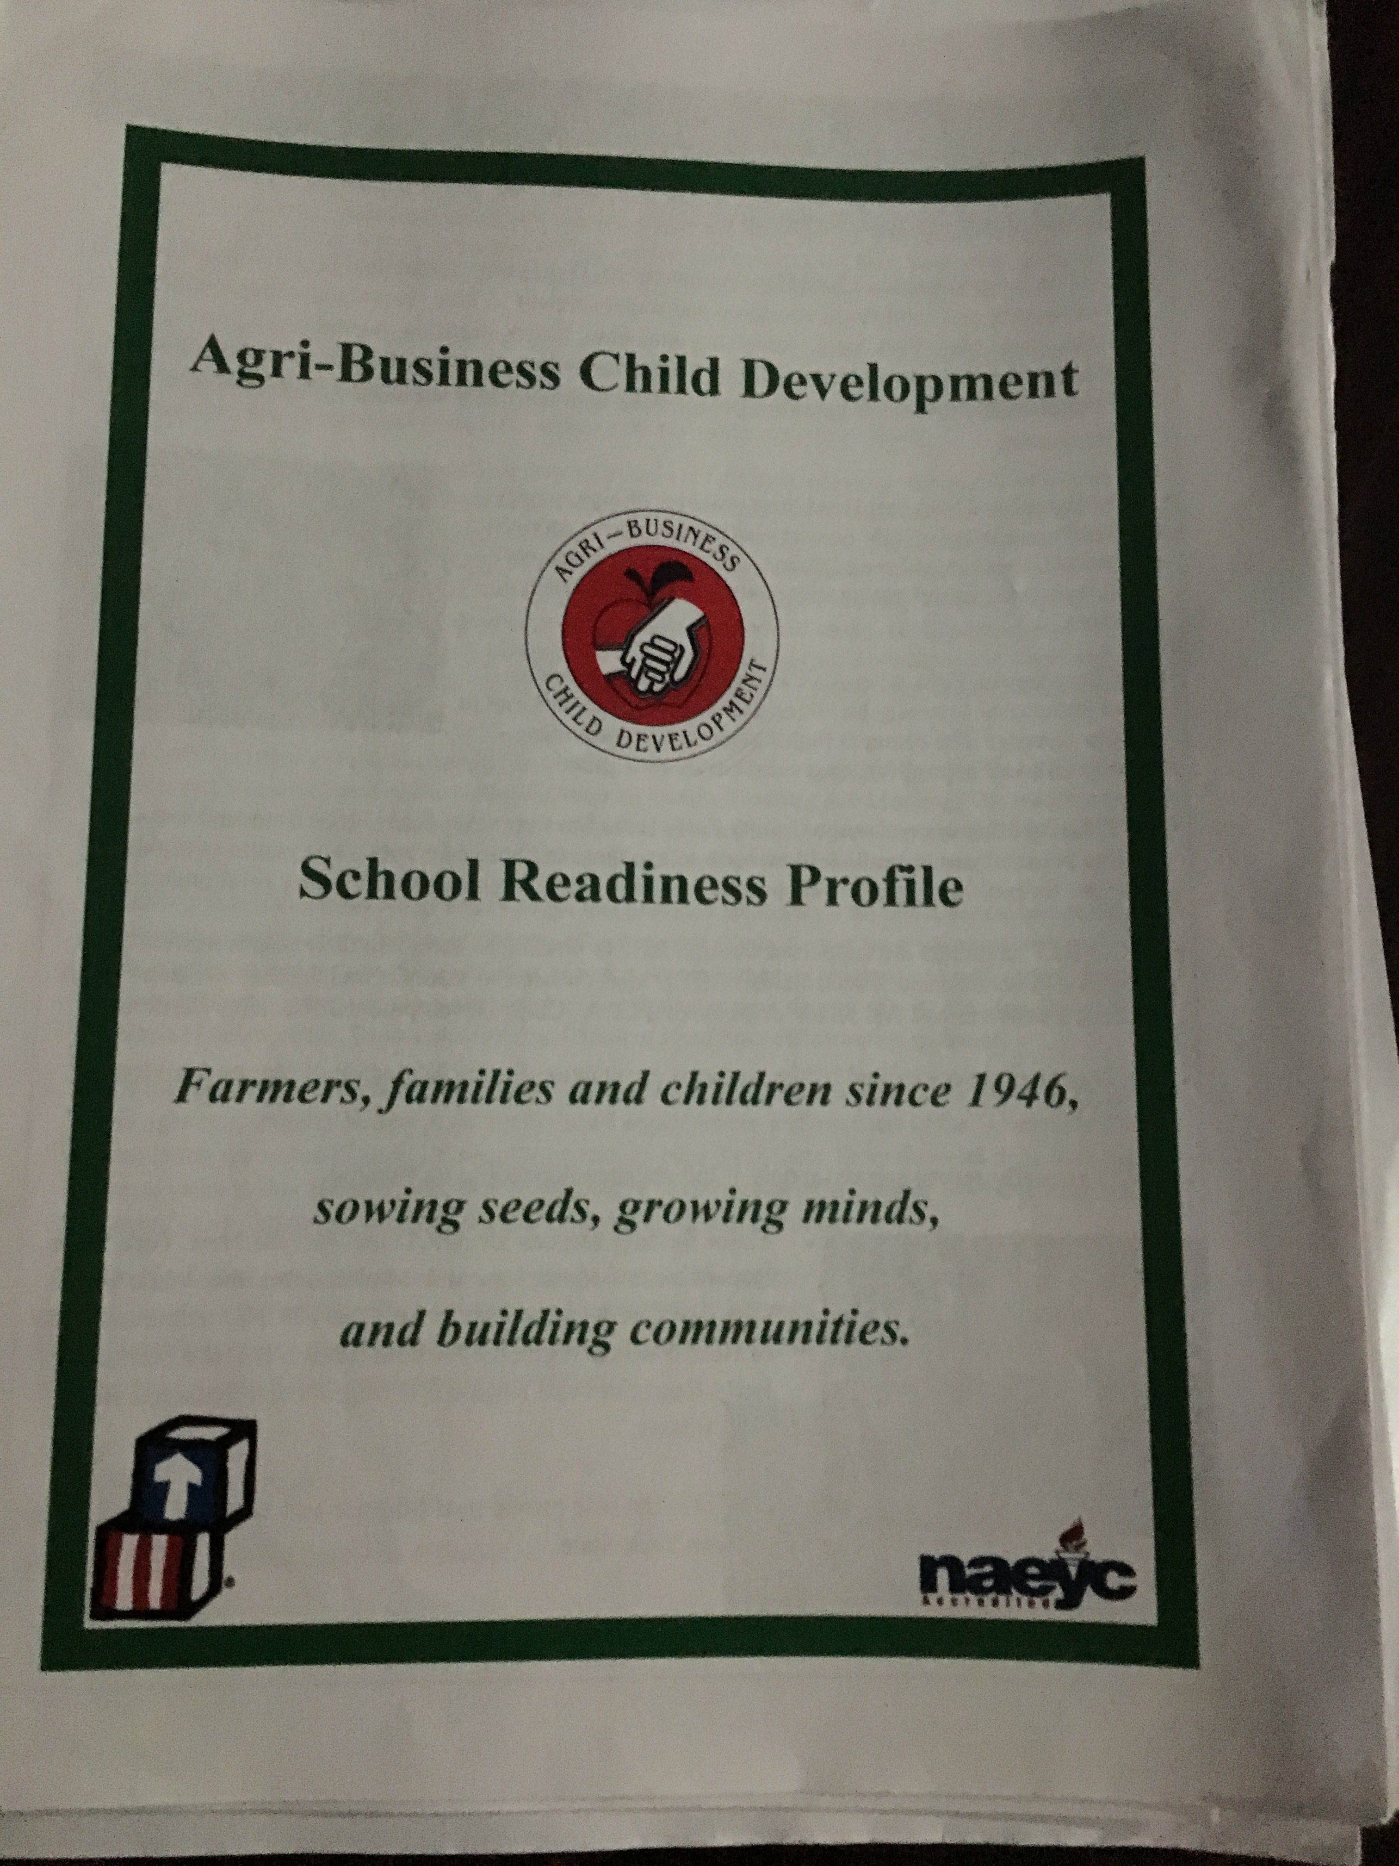
Notes

They service many migrant worker families in our area.

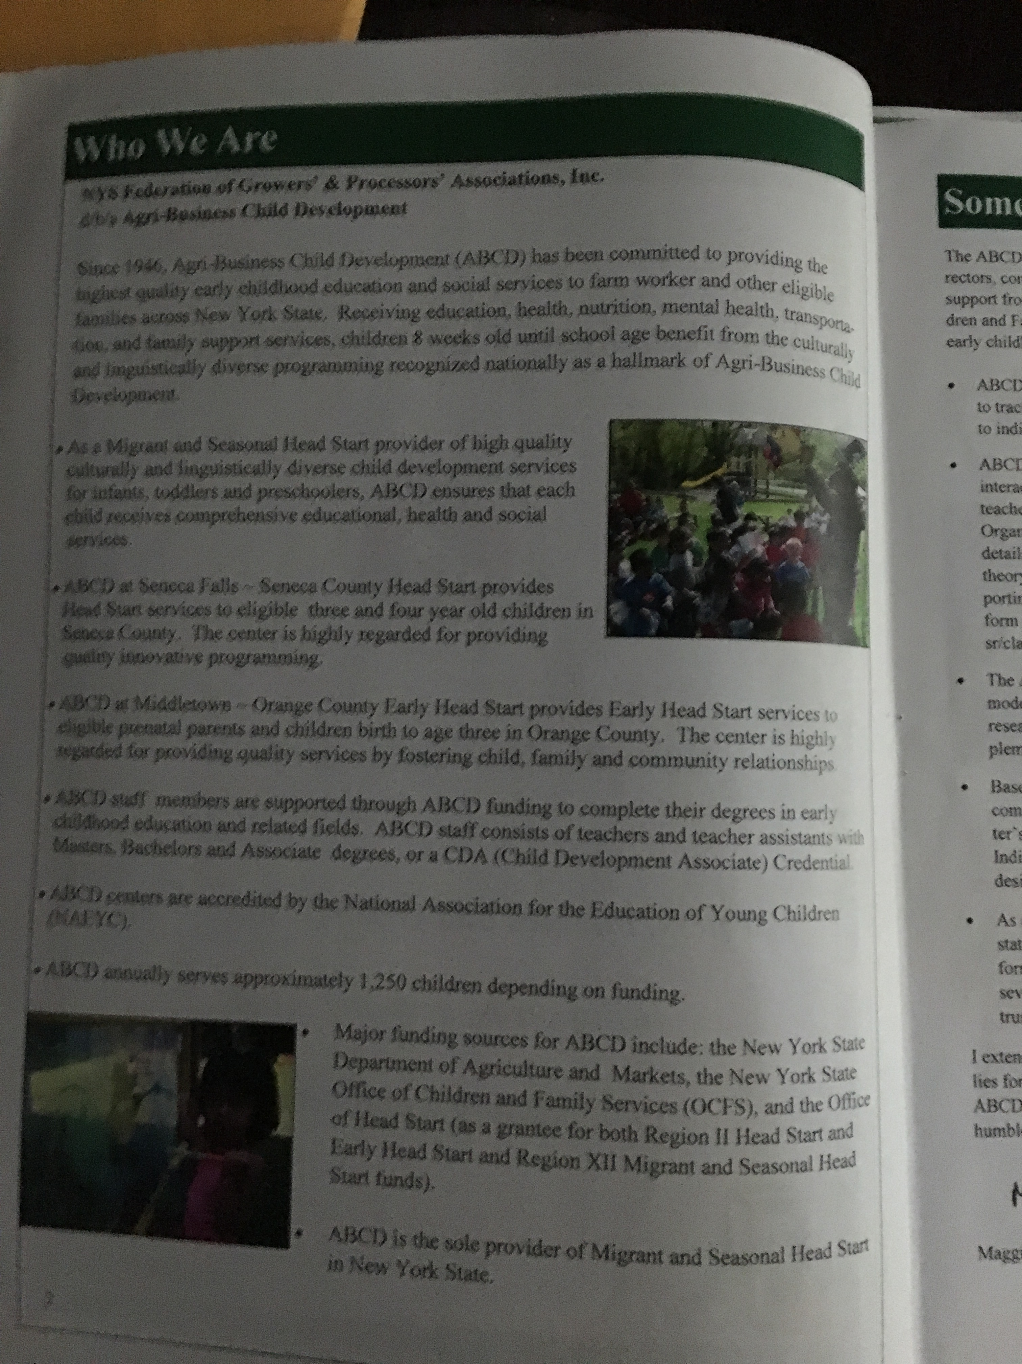
There are many different locations throughout the state of New York. Fredonia is very lucky to have one of the centers. The centers serve approximately 1, 250 families and children. ABCD is the sole provider of Migrant and Seasonal Head Start in New York State.

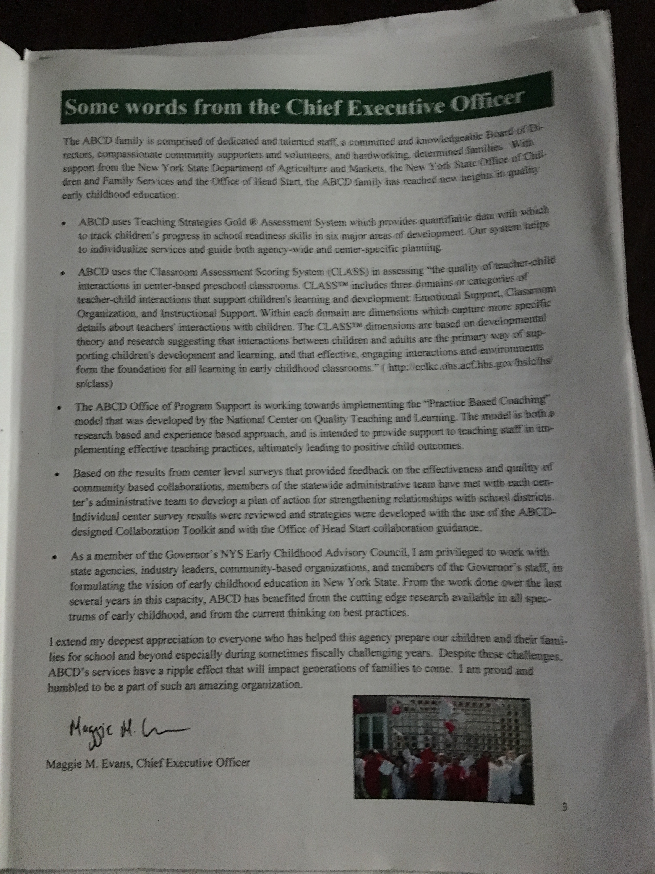
Maggie Evans is the Chief Executive Officer for ABCD. ABCD is celebrating their 70th Anniversary this year. Univision News featured ABCD's use of technology in the classroom to help preschoolers achieve school readiness goals. Google donated tablets for every ABCD center The NYS Office of New Americans facilitated this collaboration. This is a perfect example of parents, staff, business, and community and state agencies working in partnership to benefit children.

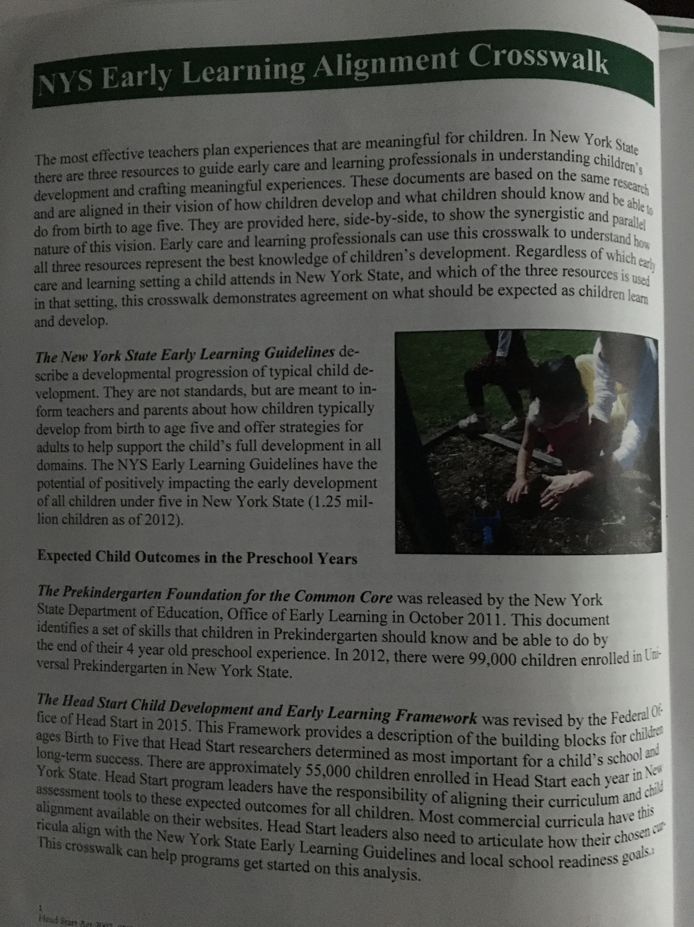
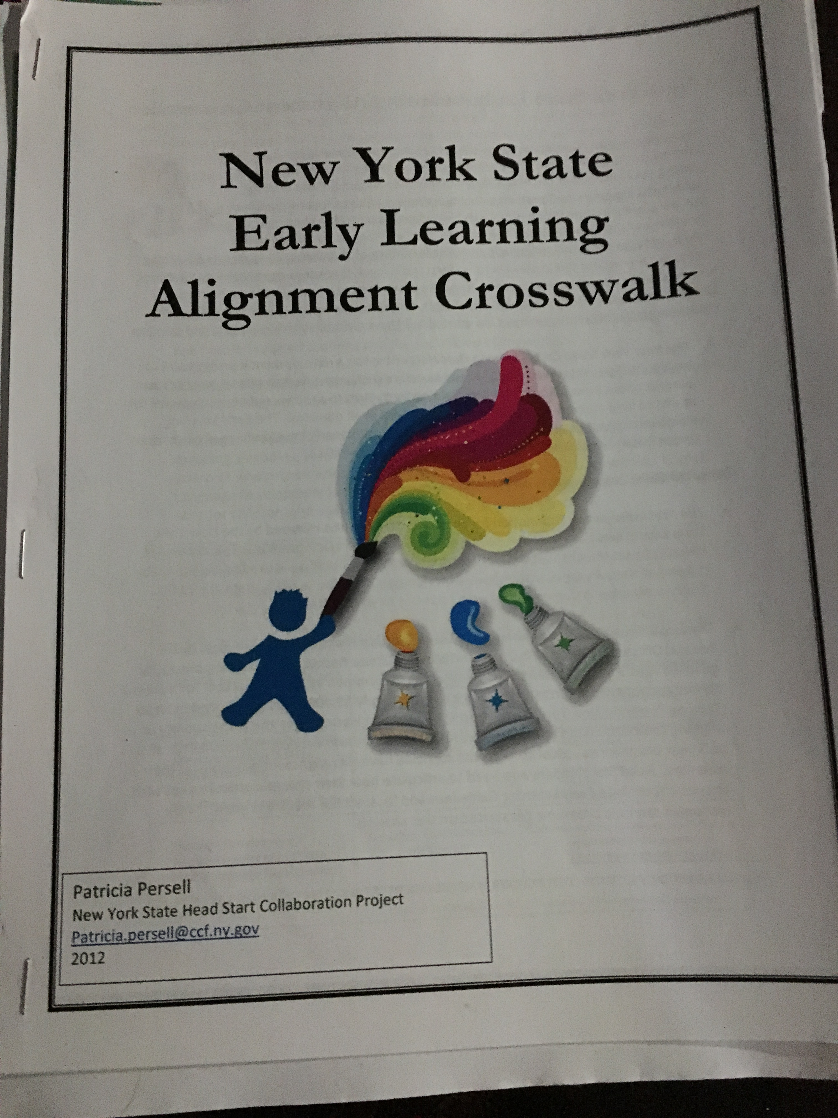
The ABCD Center Curriculum Coordinator has taken the curriculum they use at Head Start and aligned it to the Prekindergarten Common Core Curriculum Standards. This will help the children when they enter kindergarten in their local public school.

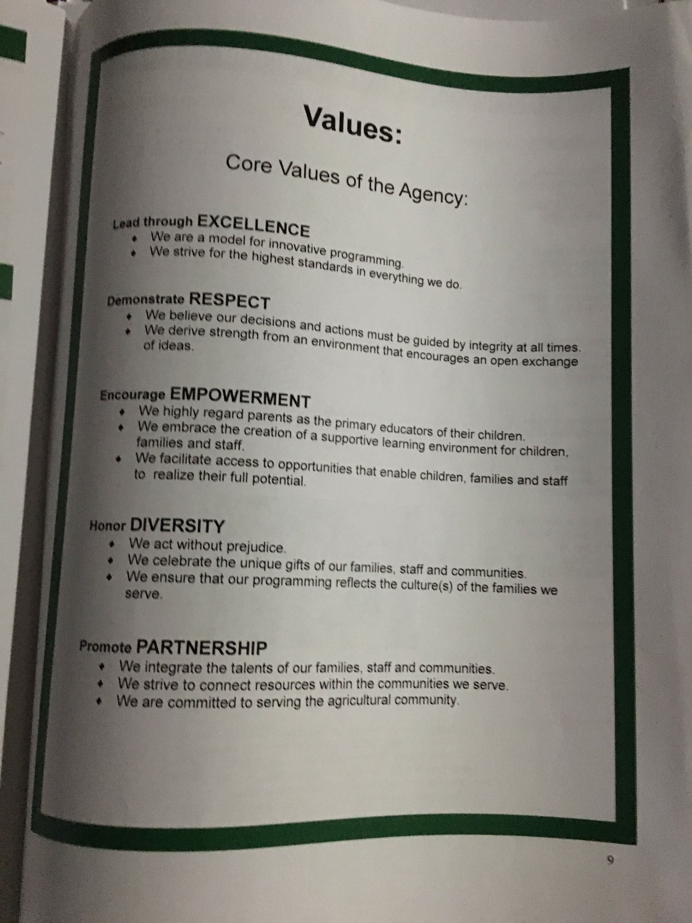
Although there are many different centers around the state and the curriculum is changing, they all continue to use the same values.

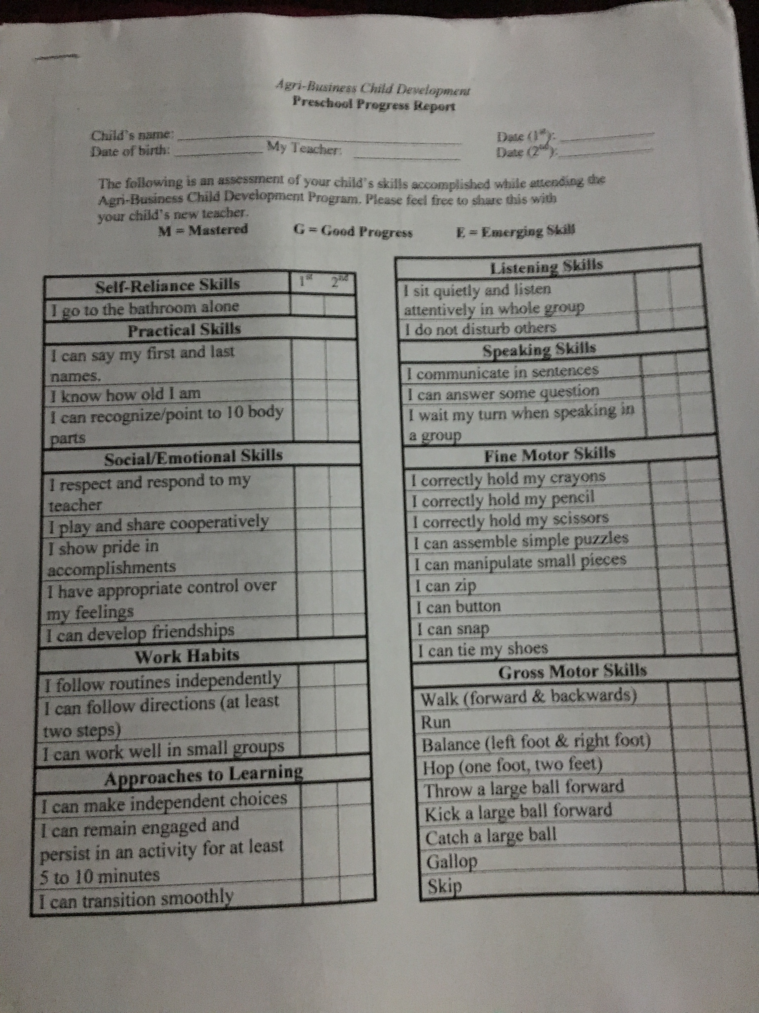
ABCD uses a Progress Report/Report Card

These are available in both Spanish and English.

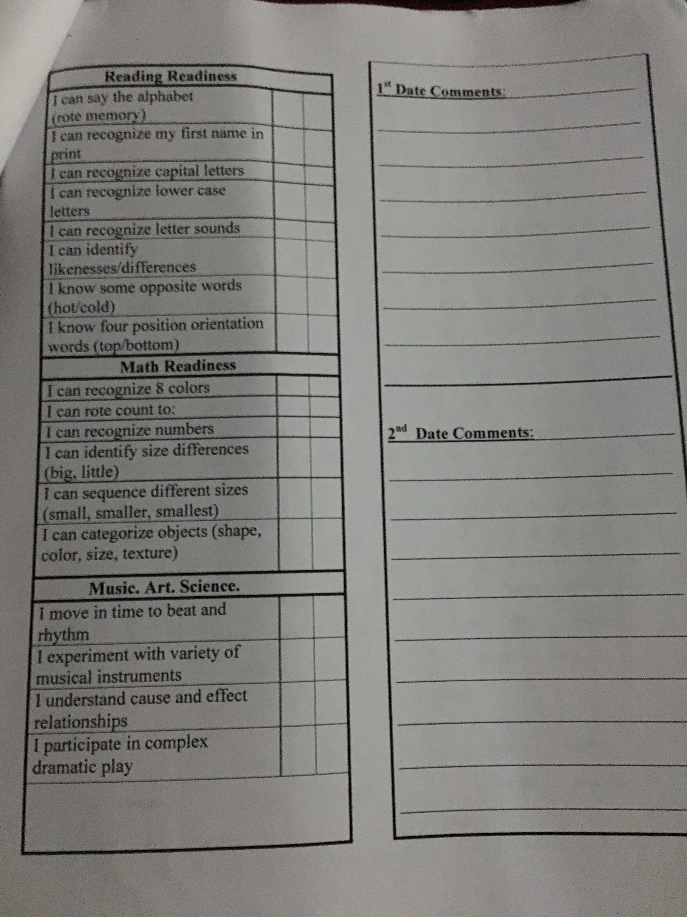
These reports are extremely helpful to our Kindergarten teachers when the students enter.

